# S1 Supplementary Results

## Carbon capture

**a) b)**

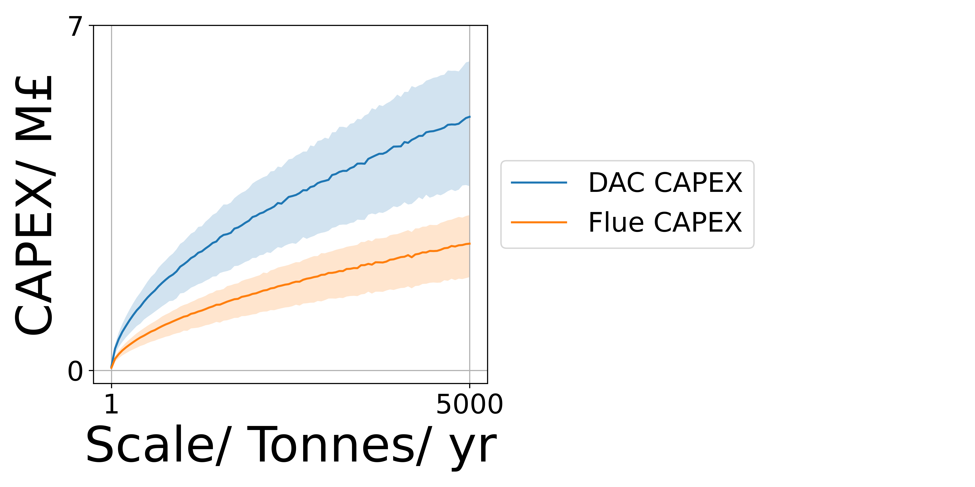 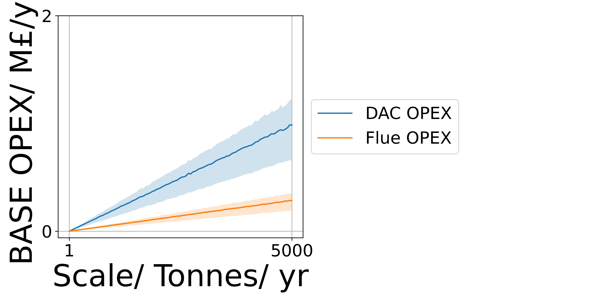

**Figure S1.1:** The effect of plant scale on Carbon Capture Subsystem CAPEX (a) and OPEX (b) **.** DAC (blue) and Flue (Orange). A reference condition of a 1 kilotonne scale, 90% capture efficiency, 20% 2nd Law efficiency and a required purity of 95% were used, all properties and parameters have an error of 50%.

**a) b)**

 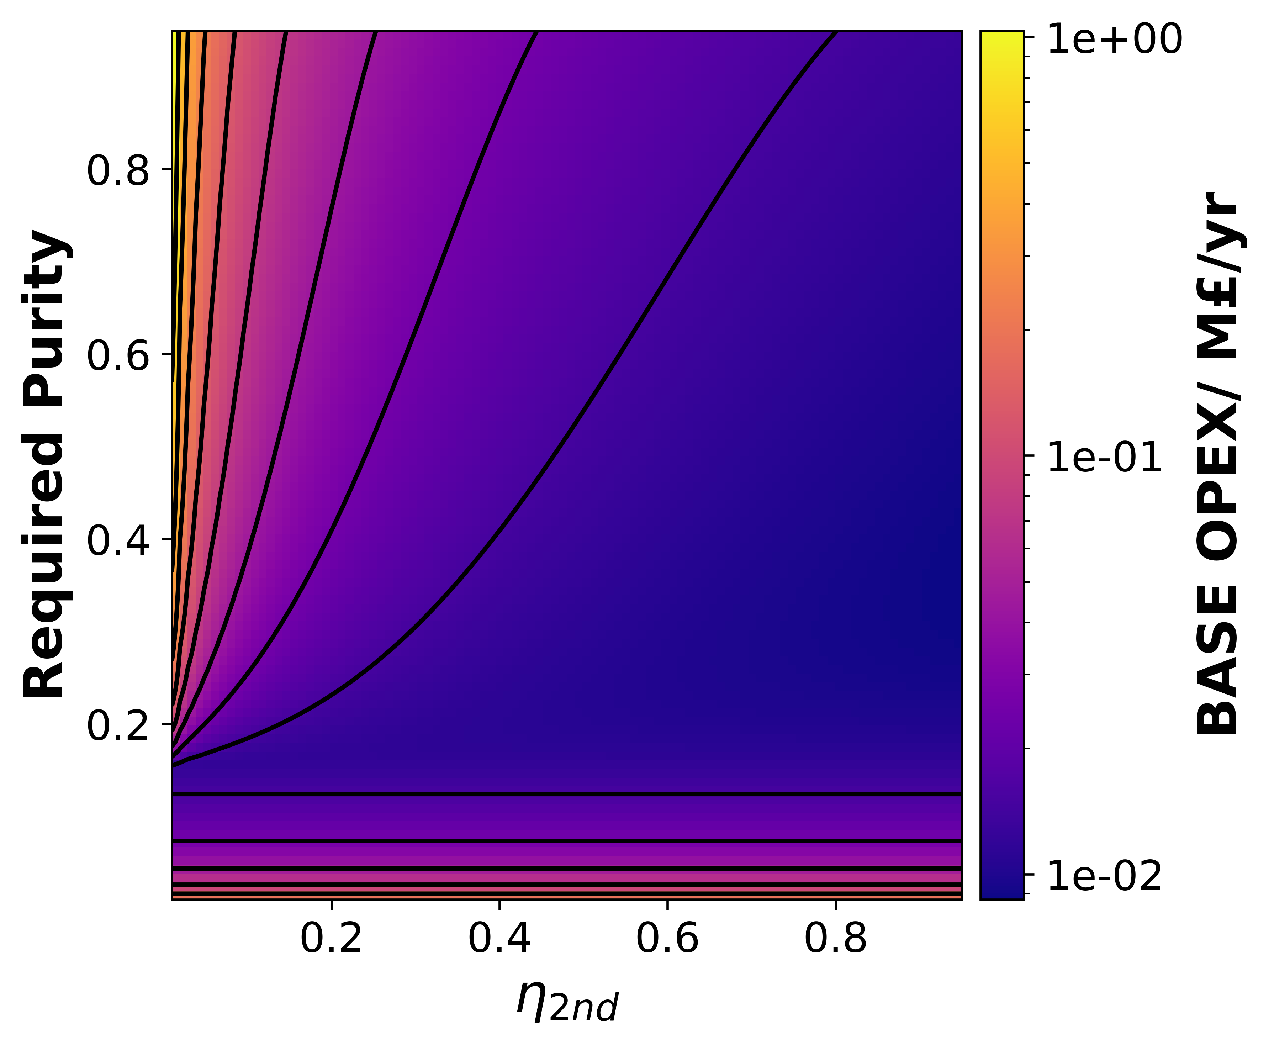

**c) d)**

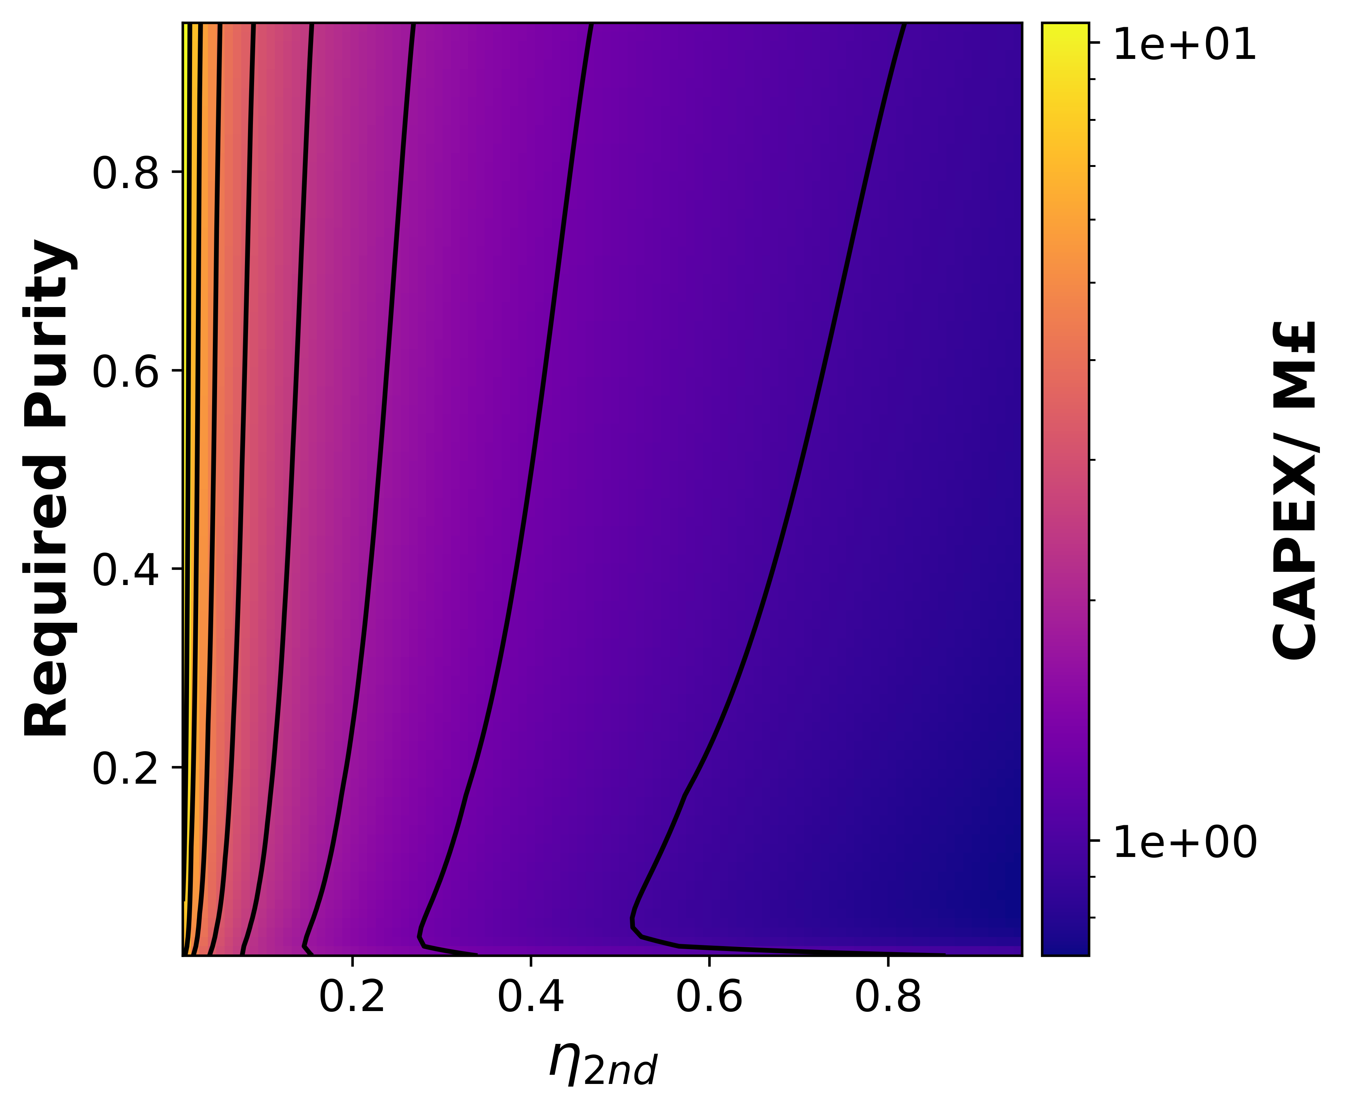 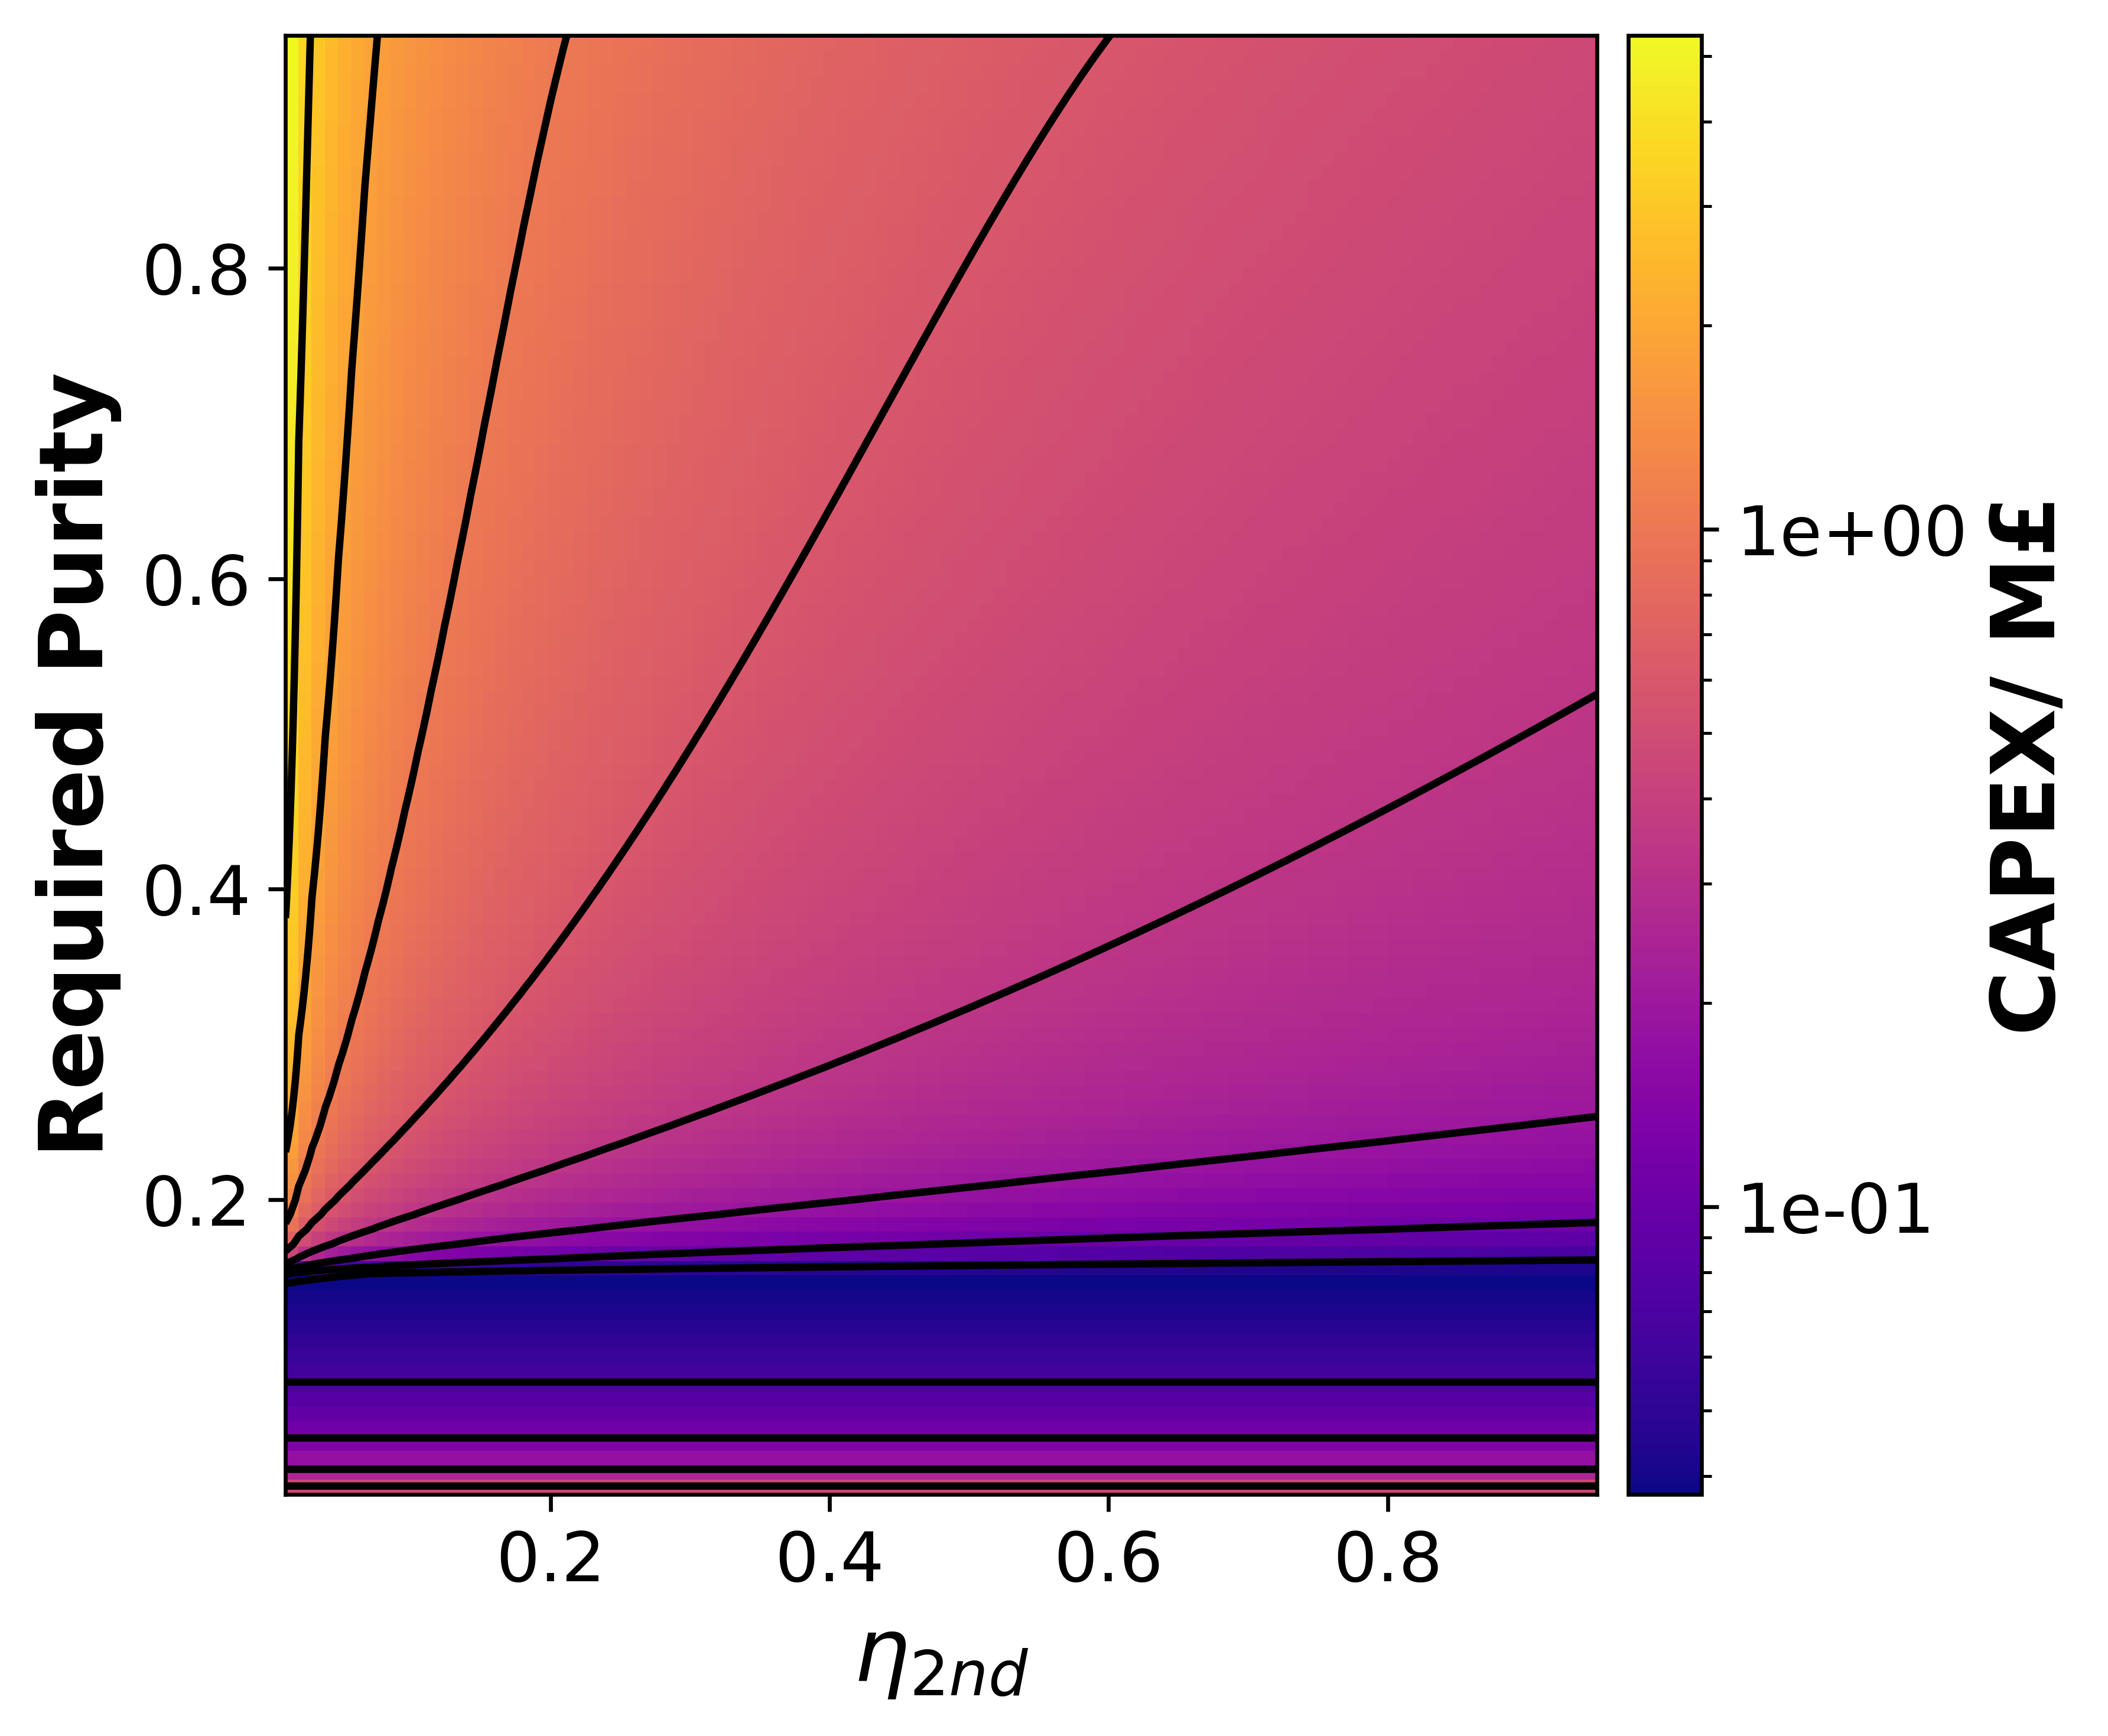

**Figure S1.2:** Colormaps to show the efect of Required Purity and 2nd Law efficiencey on OPEX (a,b) and CAPEX (c,d) for the Carbon capture susbsystem. Plots (a,c) are with DAC while (b,d) are with Flue gas carbon capture. A reference condition of a 1 kilotonne scale, 90% capture efficiency, 20% 2nd Law efficiency and a required purity of 95% were used, all properties and parameters were modelled deterministically.

## Reactor

**Table S1.1:** Games-Howell Post-Hoc Test Results for OPEX Comparison Between Electrode-Membrane Combinations. This table presents the operating expenditure (OPEX) comparison between different electrode-membrane combinations using Welch's ANOVA followed by Games-Howell post-hoc tests. The columns show: which groups are being compared (Group A, Group B); their average costs (mean(A), mean(B)); the cost difference between groups (diff); standard error of this difference (se); t-statistic (T) and degrees of freedom (df) from statistical testing; p-value (pval) with significant differences marked by asterisks; Hedges' g effect size (hedges) showing the magnitude of differences; and probabilities of one group having higher costs than the other (P(A>B), P(B>A)). The analysis reveals highly significant differences (Welch's ANOVA p-value: 4.315e-268) in OPEX across the various configurations. Carbon fiber (CF) electrodes paired with different membrane materials (Nafion, EarthWare, and BioChar) consistently show higher operational costs compared to reticulated vitreous carbon (RVC) alternatives with the same membrane materials. CF+EarthWare exhibited the highest mean OPEX (5.790), while RVC+Nafion showed the lowest (4.261). The largest cost differential was observed between CF+EarthWare and RVC+Nafion (diff = 1.528), with an extremely high statistical significance (p = 3.711e-13) and a large effect size (Hedges' g = 2.030). Within electrode type groups, significant differences were also observed between different membrane materials, suggesting that membrane selection significantly impacts operational expenditure.

|  |  |  |  |  |  |  |  |  |  |  |  |
| --- | --- | --- | --- | --- | --- | --- | --- | --- | --- | --- | --- |
| Group A | Group B | mean(A) | mean(B) | diff | se | T | df | pval | hedges | P(A>B) | P(B>A) |
| CF+BioChar | CF+EarthWare | 5.708 | 5.790 | -0.082 | 0.044 | -1.853 | 999.606 | 4.320e-01 | -0.117 | 0.465 | 0.535 |
| CF+BioChar | CF+Nafion | 5.708 | 5.492 | 0.216 | 0.043 | 4.963 | 997.109 | 1.209e-05* | 0.313 | 0.594 | 0.406 |
| CF+BioChar | RVC+BioChar | 5.708 | 4.462 | 1.246 | 0.049 | 25.306 | 969.268 | 1.000e-300* | 1.598 | 0.862 | 0.138 |
| CF+BioChar | RVC+EarthWare | 5.708 | 4.598 | 1.110 | 0.049 | 22.543 | 968.990 | 2.031e-13* | 1.423 | 0.834 | 0.166 |
| CF+BioChar | RVC+Nafion | 5.708 | 4.261 | 1.447 | 0.048 | 30.169 | 982.410 | 1.000e-300* | 1.905 | 0.899 | 0.101 |
| CF+EarthWare | CF+Nafion | 5.790 | 5.492 | 0.298 | 0.043 | 6.918 | 998.844 | 1.225e-10* | 0.437 | 0.616 | 0.384 |
| CF+EarthWare | RVC+BioChar | 5.790 | 4.462 | 1.328 | 0.049 | 27.189 | 962.556 | 1.369e-13* | 1.717 | 0.874 | 0.126 |
| CF+EarthWare | RVC+EarthWare | 5.790 | 4.598 | 1.192 | 0.049 | 24.402 | 962.255 | 1.998e-14* | 1.541 | 0.848 | 0.153 |
| CF+EarthWare | RVC+Nafion | 5.790 | 4.261 | 1.528 | 0.048 | 32.149 | 977.048 | 3.711e-13* | 2.030 | 0.916 | 0.084 |
| CF+Nafion | RVC+BioChar | 5.492 | 4.462 | 1.030 | 0.048 | 21.377 | 949.880 | 1.000e-300* | 1.350 | 0.817 | 0.183 |
| CF+Nafion | RVC+EarthWare | 5.492 | 4.598 | 0.894 | 0.048 | 18.556 | 949.544 | 1.223e-13* | 1.172 | 0.784 | 0.216 |
| CF+Nafion | RVC+Nafion | 5.492 | 4.261 | 1.231 | 0.047 | 26.257 | 966.453 | 1.047e-13* | 1.658 | 0.869 | 0.131 |
| RVC+BioChar | RVC+EarthWare | 4.462 | 4.598 | -0.135 | 0.053 | -2.534 | 999.999 | 1.153e-01 | -0.160 | 0.467 | 0.533 |
| RVC+BioChar | RVC+Nafion | 4.462 | 4.261 | 0.201 | 0.052 | 3.845 | 997.949 | 1.779e-03* | 0.243 | 0.567 | 0.433 |
| RVC+EarthWare | RVC+Nafion | 4.598 | 4.261 | 0.336 | 0.052 | 6.434 | 997.871 | 2.884e-09* | 0.406 | 0.610 | 0.390 |

**Table S1.2:** Games-Howell Post-Hoc Test Results for CAPEX Comparison Between Electrode Materials.This table presents a comprehensive comparison of capital expenditure (CAPEX) between different electrode materials using Welch's ANOVA followed by Games-Howell post-hoc tests. The analysis shows statistically significant differences (p < 0.05) in CAPEX between multiple electrode configurations, particularly between carbon fiber (CF) and reticulated vitreous carbon (RVC) based materials. CF-based electrodes generally demonstrated higher CAPEX values compared to RVC-based alternatives, with CF+Nafion showing the highest mean CAPEX (11.995) among all tested materials. The extremely low p-value (1.242e-246) from the initial Welch's ANOVA indicates strongly significant differences across the entire dataset.

|  |  |  |  |  |  |  |  |  |  |  |  |
| --- | --- | --- | --- | --- | --- | --- | --- | --- | --- | --- | --- |
| Group A | Group B | mean(A) | mean(B) | diff | se | T | df | pval | hedges | P(A>B) | P(B>A) |
| CF+BioChar | CF+EarthWare | 11.356 | 11.074 | 0.282 | 0.308 | 0.915 | 999.914 | 9.428e-01 | 0.058 | 0.515 | 0.485 |
| CF+BioChar | CF+Nafion | 11.356 | 11.995 | -0.639 | 0.310 | -2.059 | 999.966 | 3.101e-01 | -0.130 | 0.458 | 0.542 |
| CF+BioChar | RVC+BioChar | 11.356 | 6.734 | 4.622 | 0.221 | 20.931 | 517.746 | 8.959e-14* | 1.322 | 0.816 | 0.184 |
| CF+BioChar | RVC+EarthWare | 11.356 | 6.763 | 4.593 | 0.221 | 20.796 | 518.289 | 1.299e-13* | 1.313 | 0.811 | 0.189 |
| CF+BioChar | RVC+Nafion | 11.356 | 7.751 | 3.605 | 0.222 | 16.250 | 527.242 | 1.000e-300* | 1.026 | 0.716 | 0.284 |
| CF+EarthWare | CF+Nafion | 11.074 | 11.995 | -0.921 | 0.309 | -2.980 | 999.771 | 3.491e-02* | -0.188 | 0.434 | 0.566 |
| CF+EarthWare | RVC+BioChar | 11.074 | 6.734 | 4.340 | 0.219 | 19.835 | 518.078 | 9.148e-14* | 1.252 | 0.801 | 0.199 |
| CF+EarthWare | RVC+EarthWare | 11.074 | 6.763 | 4.311 | 0.219 | 19.698 | 518.632 | 1.000e-300* | 1.244 | 0.791 | 0.209 |
| CF+EarthWare | RVC+Nafion | 11.074 | 7.751 | 3.323 | 0.220 | 15.116 | 527.752 | 1.000e-300* | 0.954 | 0.690 | 0.310 |
| CF+Nafion | RVC+BioChar | 11.995 | 6.734 | 5.261 | 0.222 | 23.689 | 517.539 | 6.994e-14* | 1.496 | 0.901 | 0.099 |
| CF+Nafion | RVC+EarthWare | 11.995 | 6.763 | 5.232 | 0.222 | 23.553 | 518.076 | 1.000e-300* | 1.487 | 0.899 | 0.101 |
| CF+Nafion | RVC+Nafion | 11.995 | 7.751 | 4.244 | 0.223 | 19.022 | 526.925 | 2.049e-13* | 1.201 | 0.787 | 0.213 |
| RVC+BioChar | RVC+EarthWare | 6.734 | 6.763 | -0.029 | 0.042 | -0.692 | 999.773 | 9.828e-01 | -0.044 | 0.481 | 0.519 |
| RVC+BioChar | RVC+Nafion | 6.734 | 7.751 | -1.017 | 0.046 | -21.899 | 957.265 | 1.000e-300* | -1.383 | 0.174 | 0.826 |
| RVC+EarthWare | RVC+Nafion | 6.763 | 7.751 | -0.988 | 0.047 | -21.152 | 962.701 | 1.000e-300* | -1.335 | 0.176 | 0.824 |

1. Separation

**a) b)**

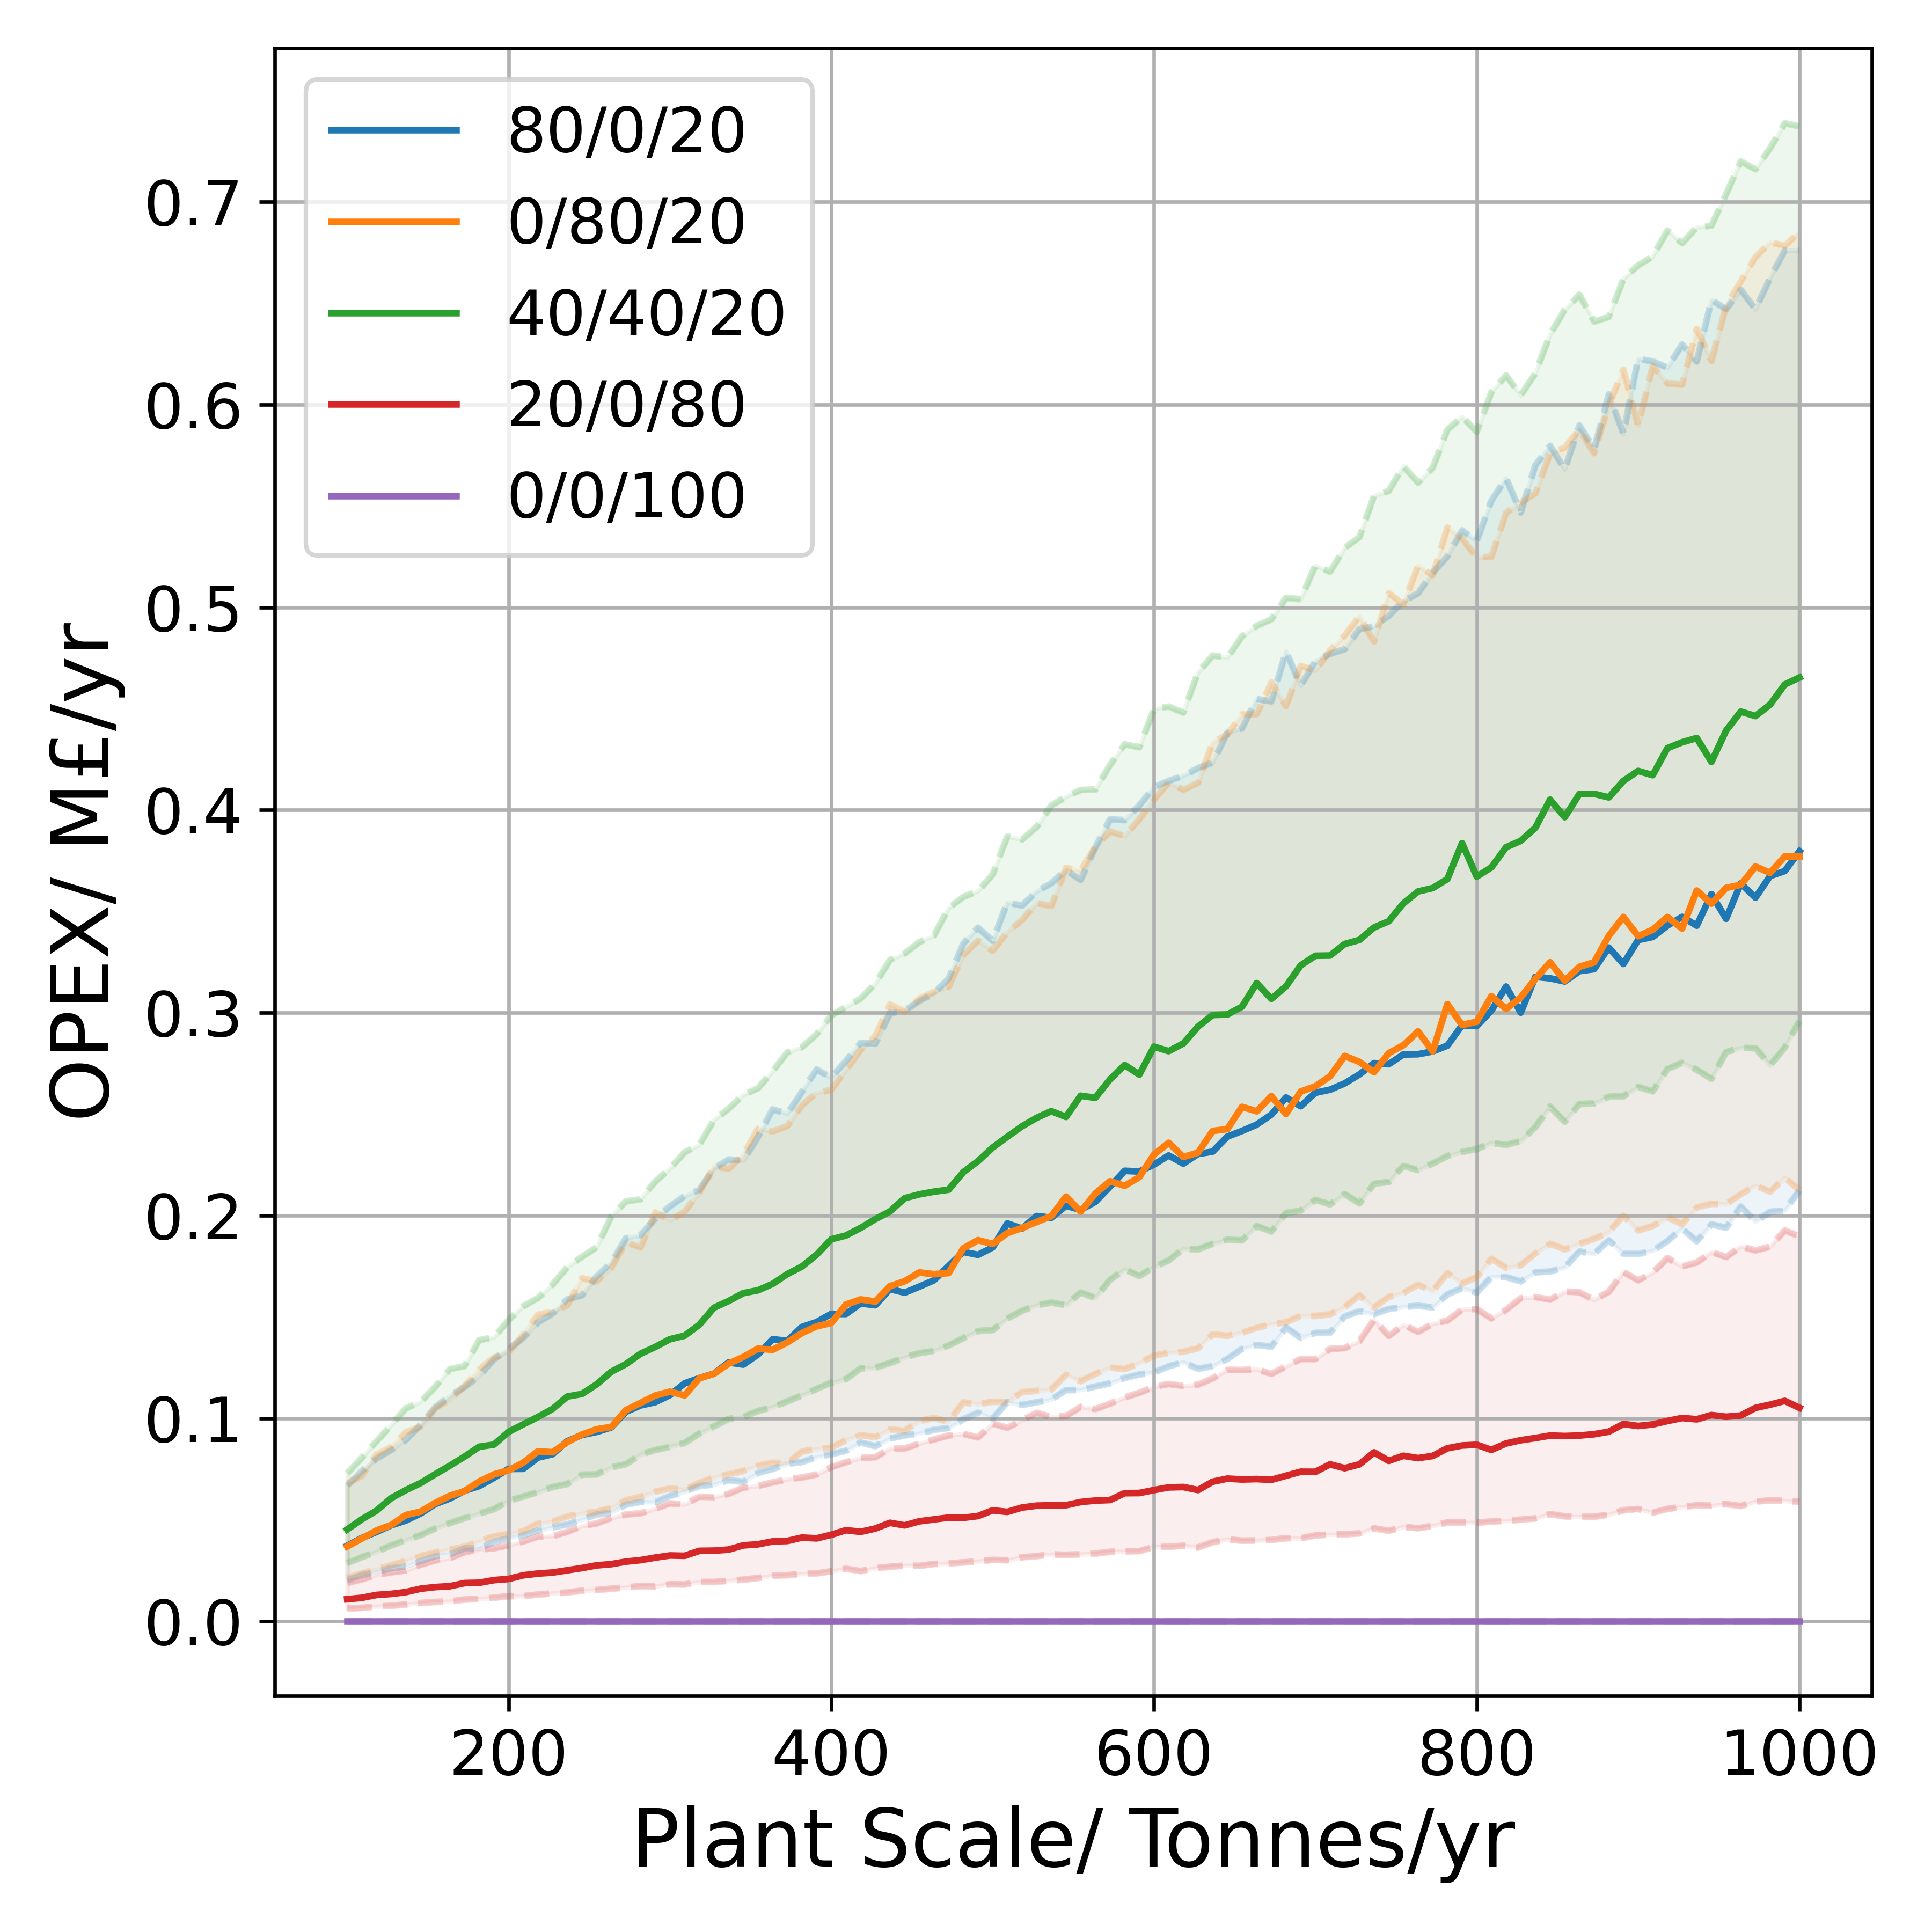 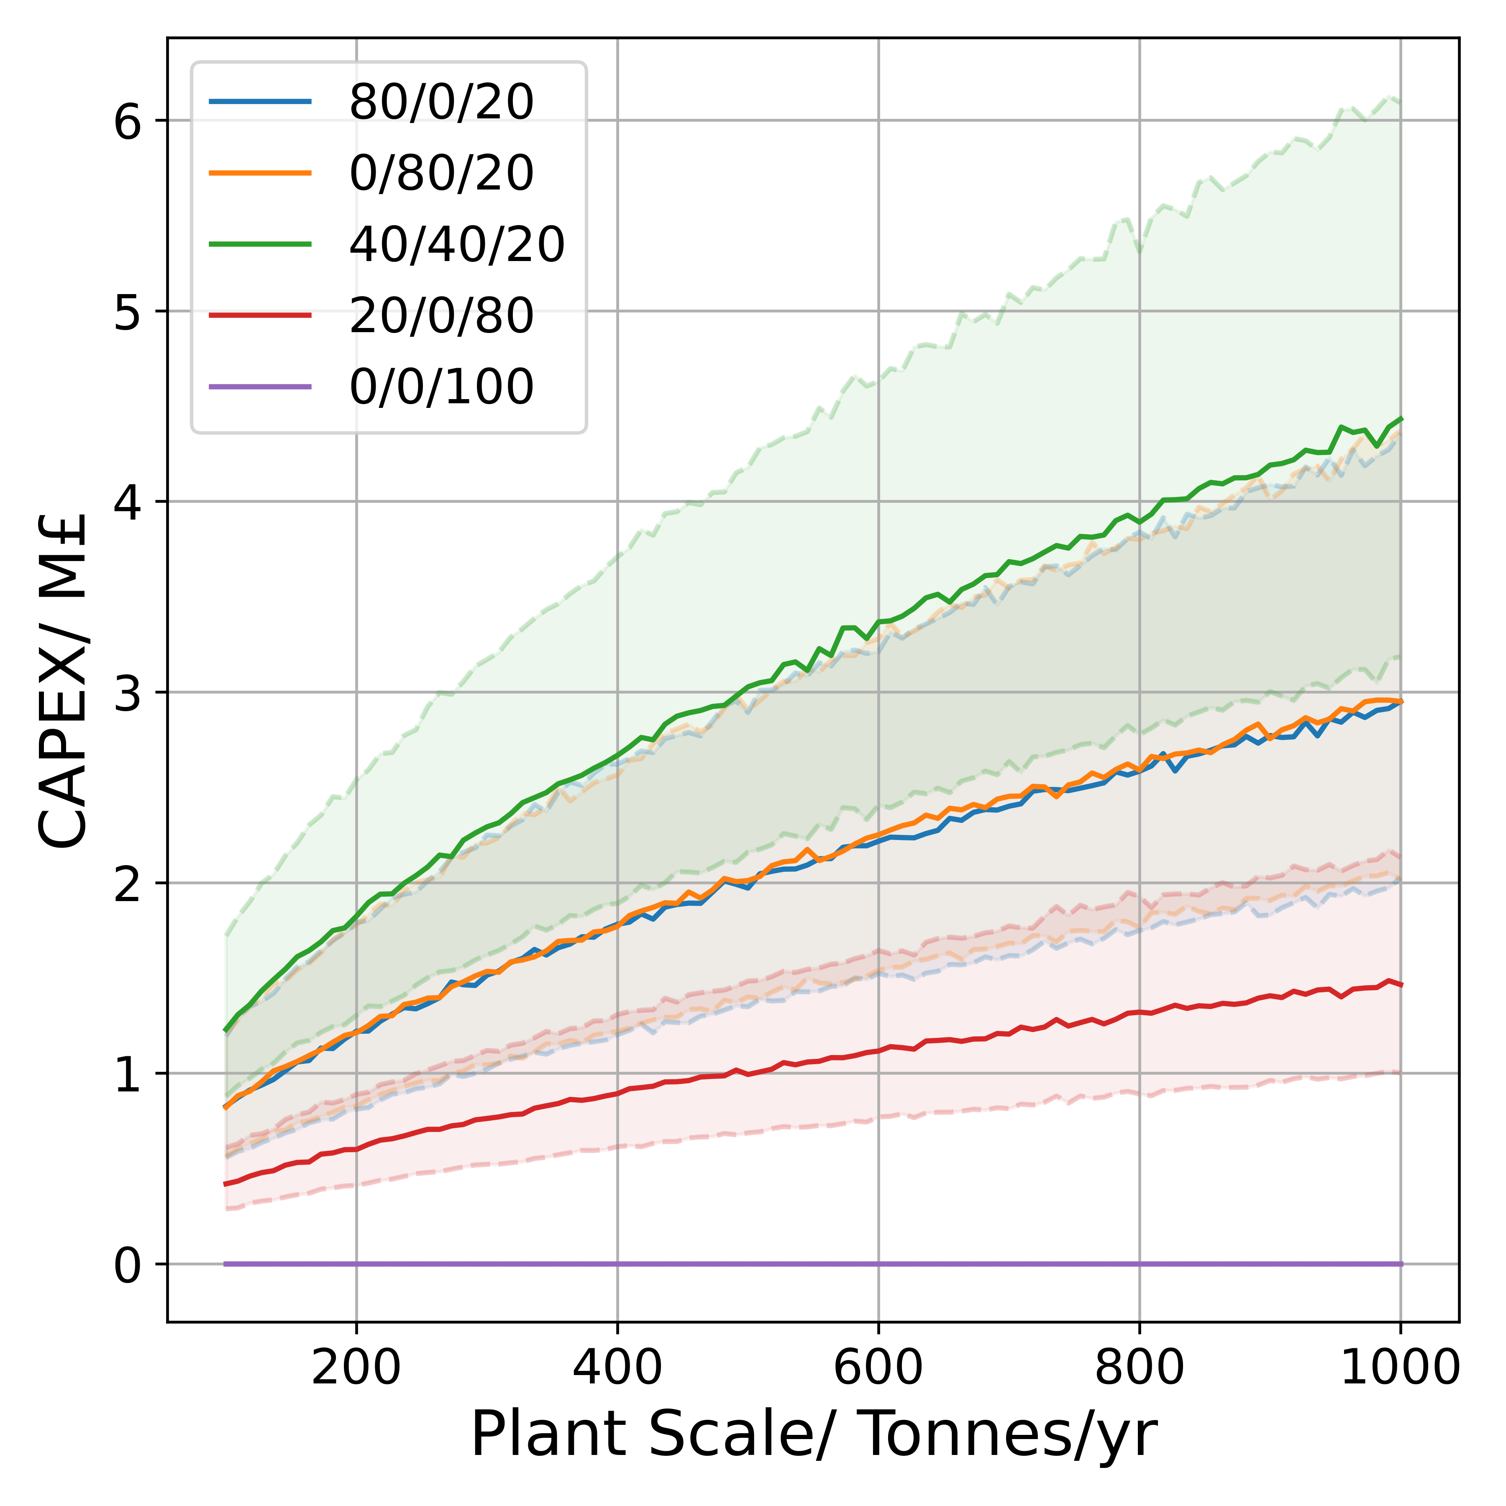

**Figure S1.3:** Plots of Separation subsystem OPEX **(a)**, & CAPEX**(b)** for a range of scales with different product ratios presented given in terms of %Riboflavin/%PHB/%Biomass. All other model parameters are modelled with an uncertainty of 50%.